To Stand For One’s Identity Is Not Only Women’s Right But Also A Duty

Introduction:
Pahichan-Nepal (The Identity) is a non-governmental organization based in Kathmandu, Nepal. We are committed to empower single and marginalized women with disabilities by creating a living, learning and working environment for them. We will enhance women’s skills, boost-up their confidence and enable them to live independent lives with dignity via different skill based trainings and exposure.
Goal
To empower single and marginalized women with disabilities economically, socially, politically and culturally.
Mission
Every single and marginalized woman with disabilities rediscover their own identity, live dignified lives and build an equitable community for themselves.
Objectives
- To rehabilitate single and marginalized women with disabilities so that they will be able to live in dignity and respected life with self-identity and independency.
- To provide every opportunity to strengthen the capacity of single women and marginalized with disabilities.
- To provide safer living space for dignified and independent life by providing income generating skills, reintegrate back to their society with dignified status and empowerment.
- To provide immediate psychosocial support to boost up their confidence level.
- To boost-up women skilled and support their children education.
- To develop strong Network among single women with disability at national level
What We Do
Free Volunteer service
We provide free Volunteer service for women with disability to visit hospital for health check-up
Rehabilitate women with disabilities
Through communal house, we will create living, learning and working space for single and marginalized women with disability for their independent and dignified life. Our aim is to integrate them back to the society of being an empowered woman with self-identity.
Education, Enhancement and Empowerment
Through training, orientation and providing space to implement their skill, women will develop their confident and enrolled in employment for their sustain livelihood. We will also support to the children of single women with disability in their education and integration.
Access and Advocacy
Through advocacy we will ensure the rights of single and marginalized women with disability by providing service, improve their mobility and socio-economic status. We will support them to have access in available resource, employment, health and legal aids.
Learn, lead and Link
Our women will develop their leadership quality by creating wide network in national and international forum and develop strong unity
What we did?
- Pahichan has successfully completed 5 days livelihood training. Our 10 participant, women with disability were honored with the certificate by the chief guest Ms Basundhara Bhusal, a Nepali senior comedy actor. All the participant were seemed to be immensely happy and thankful to the co-organizer Pahichan-Nepal and Sathi Shram Kendra for providing such a effective livelihood training. One of the participant Ms Apekshya, a blind women expressed her gratitude for providing an opportunity to learn the additional skill. She was thrilled and gave commitment to utilize this skill into business purpose. During 5 days, our participant were not only taught about preparing key-rings but also about team work and confidence development to promote their skill for sustainable livelihood.
Our organization 'Pahichan- Nepal' took a step towards its success by conducting its second program in which it distributed white cane to 200 blind and visually impaired person on 27th of February. We would like to give a vote of thanks to all who helped us to make our program a grand success.

- in the initiation of Pahichan, we have distributed warm clothes, Blanket and food item to Ms.Sita Pyari Tharu, a Blind women of Bardiya District. She is abundant by husband and a mother of 3 years old girl child. Due to her financial problem she couldn’t able to admit her daughter in a school so we are seeking the scholarship for little daughter and opportunities for her sustainable livelihood.
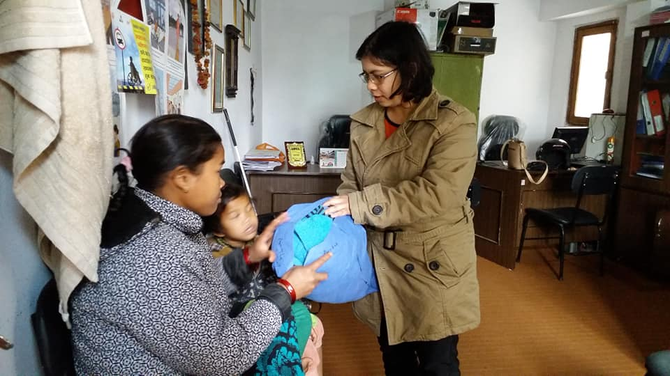
Distribution of warm Clothes, Talking watch, Rice and dal to 25 Person With Disabilities(PWDs) at different places of Gorkha.
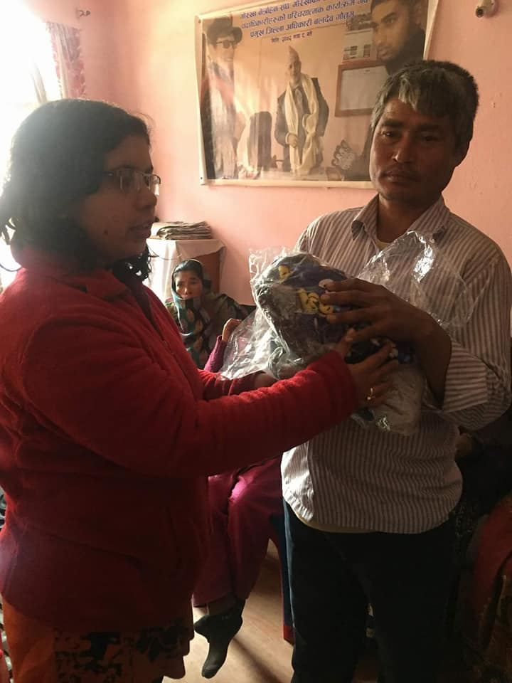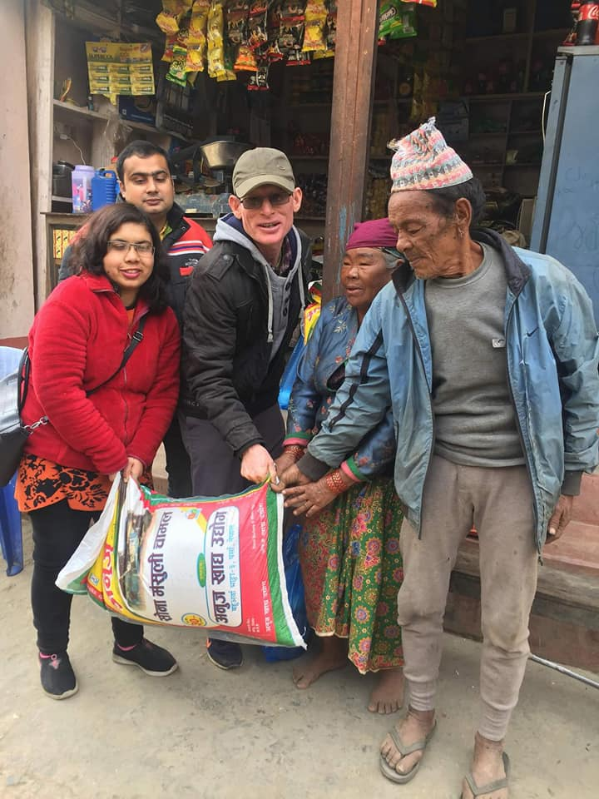
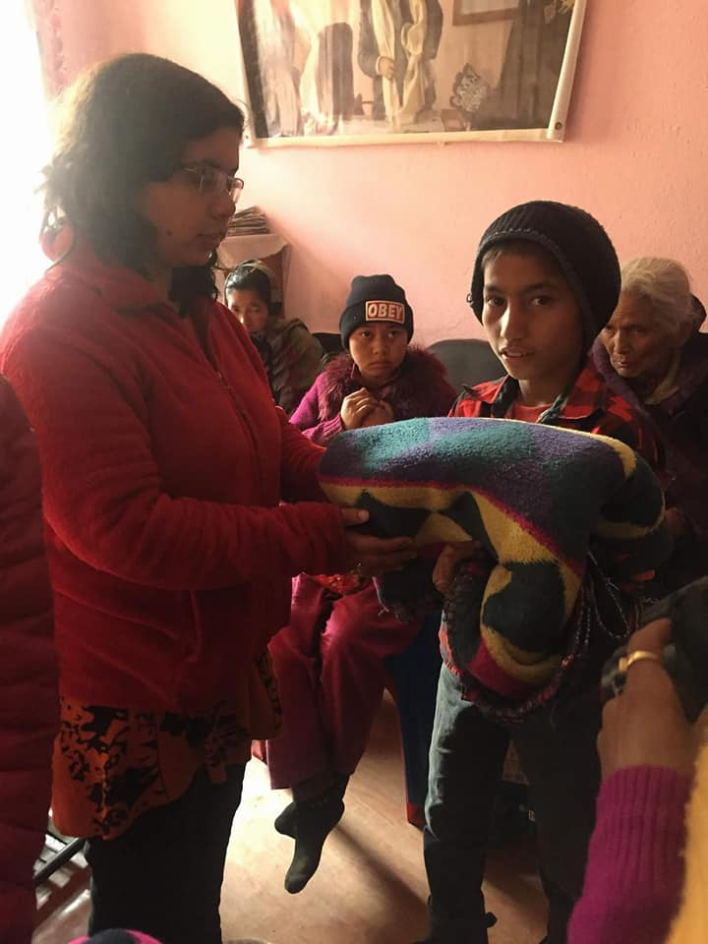

About us:
An experience of overcoming challenges and challenged the society for a change.
Pahichan-Nepal, “The Identity” is a non-governmental organization based in Kathmandu, Nepal. We are committed to empower marginalized women with disabilities through creating a communal environment where unmarried, divorced and widows live, learn and work together. It will further encourage women with disabilities in Nepal to discover their identity regardless of their marital status and disability.
Pahichan will enhance women’s skills, boost-up their confidence and enable them to live independent lives with dignity.
Our board member comprises 9 member including single women and women with disability. In Nepal, there is single women policy, guidelines, social allowance, facility and district single women committee. Since 20 years, NGO is working for the issue of single women. However, women with disability have not access on it. Within the single women, marginalized and disability women are more victim and under privilege. There is an assortment of stigma, superstition and ignorance that are associated with disability. The beauty and relevance of all this in our life has come from the fact that being discriminated, or even worse, having the feeling of not being valued, has resulted in making a stronger, resolute woman of ourselves. From our own experienced and our friend, we have acknowledge the fact that “Nothing about us, without us”. Therefore, in the initiation of Ms Ichhya K.C a Nepali blind woman, an active group member of single and marginalized women with disability committee has been formulated in 2017. Since, we have started to raise the issue and rights of single and marginalized women with disability. We have conducted several workshop in the participation and collaboration of Ujyalo Foundation, Women for Human Rights (WHR), Blind Women Association, Nepal Disabled Women Association and Department of children and Women.
From our research, we have found the significant on the issue of single women with disability and its project validity. After graduate from ‘Kanthari institution’ course 2018, a renowned international leadership, intensive training program; Ichhya has decided to convert that strong committee into organization strength. Then, on Feb, 2019 Pahichan -Nepal (The Identity) has been legally registered. Now Pahichan-Nepal is working continuously as a Social Enterprise that would eventually make meaningful impact in the society.
In Nepal, women’s role is restricted to taking care of the husband’s house, giving birth to his babies and nurturing cultural practices. Strict patriarchal system, norms, religious practice and social boundaries hinder women from being active, contributing agents in society.
Women with disabilities, face the double brunt of patriarchy as well as the stigma associated with having disabilities. Women with disabilities are often considered as marriageable and are seen as weak members of the society. However, Pahichan will utilize this state of affairs as an advantage. We will encourage women with disabilities in Nepal to discover their independent identity regardless of their marital status and shall strive to upgrade their living status.
About Founder:
Ichhya KC, founder of Pahichan (www.pahichan.org), 2018 kanthari participant, Nepal
Icchya has been active in advocating for the disabled in Nepal. She sees the need to empower single women with disabilities like herself. She wants to establish a safe space that offers psycho-social, legal and rehabilitative support mechanisms to single women with disabilities, to help them overcome discrimination and find their own voice in society.
Background and Problem analysis:
Background and justification
Persons with disabilities in Nepal are facing higher incidence of human rights violations specially women in comparison to men, shows by different studies. Discrimination and unequal treatment, patriarchal society and mannish nature, disregard for difference, abrasion of dignity, denial of accessibility and exclusion. belonging to the marital status and poverty whether in urban or rural areas, the victimization and human rights violations occur, the incident of reporting to proper authorities is diminutive due to lack of confidence that something positive will happen, lack of knowledge on how and where to report, avoidance of unnecessary trouble, and the negative attitude of society to disclose the issue. The media also have negligible news coverage on the human rights violation of single women with disabilities.
According to the census of 2011 of Nepal, there is 1.94% of total population with disability. Out of the total population of disability, 45% of them are women. The experience of organization working in disability sector assumed that only 30% of them got married but out of them only 5 to 10% of married women are enjoying their marital life.
Most of the married women (WwDs) are left by their husband in the mid-way of their marital life. Similarly, those women whose husband is passed away and unmarried women of 35 age are living harsh and discriminated life. They are considered as a single woman and their family and society let them live isolated life. They couldn’t live respectful and dignified life. They are not aware of law and policy for their own rights. Similarly, they have no income source and are not in position to able to enroll in job, either lacking education or skills required. For that reason, they are mostly avoided from their family members and also lack to access their property rights. Due to this, some of they are suffering from depression and seeking support to overcome the situation and enjoying the life in comparative better situation. For instance, Gita (Name changed) is a widow blind woman of 47 years old from Kathmandu. She has a ten years old son who stays in an institution. She stays with her in-laws but they never take care of her, they let her live in a tiny congested room away from the family. She is living there alone after the earthquake whereas, other family member is living together in a big building. She received a vocational training from one organization. After completion of the training she had started working with same organisation with very small salary of NRS 2,800/month even though she has been working there for 2 and a half years.
This small income is not enough for her expenses; she is struggling to manage even one-time food a day beside that she is suffering from domestic violence. Research shows that the single women with disabilities are often at greater risk, both within and outside the home, of violence, injury or abuse, neglect or negligent treatment, maltreatment or exploitation, and expresses concern about the difficult conditions faced by persons with disabilities who are subject to multiple or intensified forms of discrimination. Article 6 of the Convention on the Rights of Persons with Disabilities obligate the state parties recognize that women and girls with disabilities are subject to multiple discrimination, and in this regard shall take measures to ensure the full and equal enjoyment by them of all human rights and fundamental freedoms. Article 10, obligated that state parties reaffirm that every human being has the inherent right to life and shall take all necessary measures to ensure its effective enjoyment by women with disabilities on an equal basis with others. In article 26 (States Parties shall take effective and appropriate measures, including through peer support, to enable persons with disabilities to attain and maintain maximum independence, full physical, mental, social and vocational ability, and full inclusion and participation in all aspects of life.
To that end, States Parties shall organize, strengthen and extend comprehensive habilitation and rehabilitation services and programs, particularly in the areas of health, employment, education and social services, through a way that of these services and program.
In analyzing situation of single-women with disability, the project critically reviewed its causes and consequences towards socialization and risk of further victimization. Isolation from the overall relegation of women within a patriarchal system and viewed physical and mental abuse against single Women with disabilities as an outcome of gender discrimination that shapes social, economic, cultural and political structures.
The constitution has covered various issues of women however particular focus to the rights of single women with disabilities is not accommodated. There are various policies and program including Domestic Violence Act (Offence and Punishment) however the coverage of specific attention to benefit single Women with disabilities is not observed. There is civil code "Dewani Samhita", various issues of women's rights have been included including property rights, marital, familial and reproductive rights and even single women policy however the concerns of single women with disabilities is overlooked.
In such circumstances, intends to execute this project comprising the activities in a range of areas, such as rights against social discrimination, physical and mental harassment and denial of right to live dignity and respectful life for single Women with disabilities. It is vital to build capabilities of the network of group of single women with disability and disability rights activists about the principles of indivisibility of rights and to a shift from differentiate -oriented approach including education, health and gender equality within the scope of their work, as part of their outstanding obligation to prevent discrimination against single Women with disabilities.
We believe that they couldn’t raise the voice against unequal practice and treated as a second citizen, on their own without an organized voice.
They need a safe place where they can exercise their rights to live with joyful and independent life. Even there is no any organization who works particularly in the issue of Single Women with disability. Viewing these circumstances, Pahichan-Nepal planned to empowering the single women with disability and ensure their equal rights within the family and society. It is to make them aware and enough capable to raise their voice and able to create their identity and space in their family.
In long term, there will be an accessible safe house with rehabilitation approach led by group of empowered women with disability for single women where they can fully be enjoying the life and exercising their rights by enhancing their capacity through different means. It mainly works in the area of social, cultural and economic rights.
Join us by:
Volunteer For Us and Supporting Us:
Address: Bhimsengola 31, Old Baneshwor, Kathmandu Nepal
Email: kc.iksha@gmail.com/ founder@pahichan.org
Website: www.pahichan.org
Mobile no: +9779841633820
Whats App: ++9779841633820
Bank Details:
Bank Name: Machhapuchchhre Bank Limited
Branch: Chabahil, Kathmandu Nepal
Account Name: Pahichan Nepal
Bank Account Number: 5601524697099016
Swift Code: MBLNNPKA

